Nationality: Algerian Abdallah Mezi
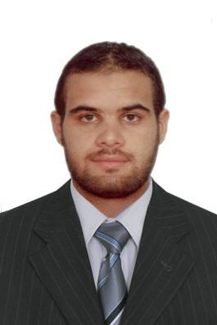

Address: Ain Oussera,Djelfa . Algeria
Phone: +213 772100724
Email: abderasak88@hotmail.com
Date of birth :09/11/1989

- Objective_________________________________________________________
I am looking for a position which fit my personal skills and qualifications and allow me to develop further and to acquire a challenging career. I am highly motivated and very adaptive

- Education_________________________________________________________University Of Blida, Algeria 2007 – 2012
BA degree in English Language
Master degree in English Arabic translation 2015 - 2017

Professional Training :
Attended English workshops held by the British Council:
- Effective Oral presentation
- Teaching Listening
- Error Correction
- Teaching Grammar in context .
- WorkExperience___________________________________________________

Teaching English
- Royal school Jan 2013 - Sep 2014
- Teaching Linguistics - university of Blida 'Part time' Oct 2012 -March2013
- Tutoring daily conversational English ( via Skype) Oct 2012 - present
- Algerian Languages Center Dec 2015-April 2016

Geometrica Inc Nov 2013 - Dec 2014
Technical English Arabic translator
  - Translating technical documents and articles for demonstrating the company’s performance in creating and designing domes and pillars and more .
Livemocha Inc Nov 2012 - June 2013
English Arabic translator/Administrative assistant

- Translating English lessons into Arabic to help Arabic learners clearly understand the difficult words and grammar rules.
- .Assisting the coordinator and managers to present their sales for Arabic companies through online meetings and conferences

Lexi Ltd
Sales Officer /interpreter Sep 2016 – Present
- Offering interpretation service for Mr Farhad ( Marketing and development manager ) and Mr Raju ( Assistant Manager ) in Algeria during their meeting with entrepreneurs, importers and wholesalers.
- Doing market research in different and main areas, shops and dealing with customers .
- Selling products by implementing sales plans; supervising sales staff.

- Languages______________________________________________________________
- Arabic : Native Speaker
- English : Professional Working Proficiency
- French : Basic

- Skills & Competencies
- Achievement & Results Orientation.
- Driving License
- Impact and Influence.
- Customer Service Orientation.
- Leadership skills.
- Team working & team building with spirit of group .
- Presentation and Communication skills.

