About Online Translation Service
Online Translation Service is an agency specializing in providing high quality language services. Whether you contact, exchange and negotiate with colleagues, partners, clients or suppliers abroad, we always understand the importance of that work. Our goal is to ensure the language your clients require to use and understand will no longer be impeded with almost absolute accuracy and perfect client service; that is all our company is dedicated to every day and every hour.

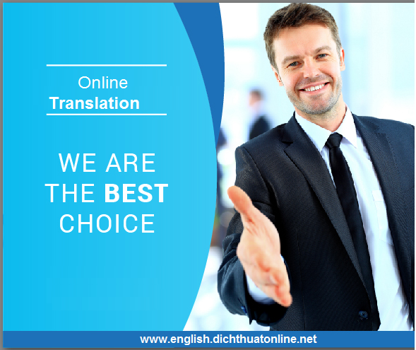

Why you should choose Online Translation?
Client focused Service: As a company with a young, dynamic, creative and caring staff, we always spend time to listen and serve our clients! Our project managers will be honored to take care of clients by phone, skype or directly talk to clients about the steps as well as work plan.
Qualified translators: Your translation will be certified by qualified translators who have at least 05 years of experience in providing the highest quality translation products in your field. All our translators have a degree in academic and professional qualifications awarded by universities specializing in language.
Qualified translations: What matters most to us is client satisfaction; we always look forward to providing services to our clients next time and so we always work hard to ensure that your translation is delivered on time, and the translated text is perfect for your work.
Native translators: With over 35 languages widely used worldwide, we have a team of indigenous people working with us in almost every country. Our professional translators translate only documents and text into their native language for the highest accuracy in terms of culture and language. For all language problems, we will contact the client when needed.
Deadline: We always continuously work to provide our clients with translations as quickly as possible while ensure perfect quality for the whole document. In case you need your translation earlier than the required time, let us know and we will have the fastest solution for our clients. In addition, we can provide instant translation services in the day when required, regardless of normal or notary translation. Please refer to the instant translation service in the day with customer service department!
With the modern and professional service style as well as the translation and interpretation staff who are enthusiastic, attentive, highly qualified, knowledgeable about many different specializations, Online Translation Service guarantees fast translation, accurate content and technical terms from each translation. Our translation services are available in 30 different languages such as English, Russian, French, Japanese, Korean, German, Chinese, Spanish, Portuguese, Lao, Thai, etc. with more than 50 fields of economics, finance, banking, bidding documents, specialized documents, projects, etc. Especially, we also provide interpretation services for conferences, seminars, cabin interpretations, trade negotiations, etc.
With a wide range of languages, our team of translators and interpreters are confident that we can meet your translation needs. In addition, we provide our clients with high quality film translation service from Vietnamese into 30 different languages and vice versa; we accept all types of CDs, DVDs, Blu-ray VCDs, video tape and data file.
Online Translation Service wishes to become one of the most prestigious and high-quality translation agencies in Vietnam, so we always provide our clients with the most perfect translation services, contributing to economic benefits for you. We look forward to being the bridge to the success of your honorable agency and enterprise.
Please contact us today to get the best service via hotline number: +84915502269

